**T-sne results (Word-level results):**

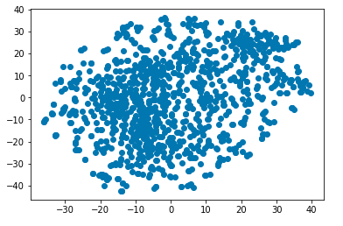

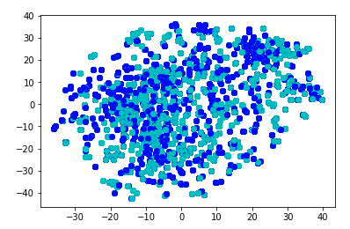

The words in the left bottom and in cyan(hate speech) are:

canadian

canada

nation

usa

country

indonesia

trans

america

australia

africa

american

African

The words in the left and in blue(not hate speech) are:

million

30,000

1,500

billions

dollars

money

300,000

800

sell

buy

paid

pay

$

pays

The words in the right up and in blue are:

disrespecting

bigots

wilfully

heathens

ms-13

memes

meme

zionists

fisting

transphobic

tricare

deers

tits

victimizes

defenceless

infidels

anus

**T-sne results (Contextual results):**

All 8500 data, 50 perplexity

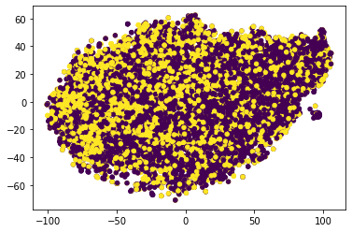

2500 data, 200 perplexity

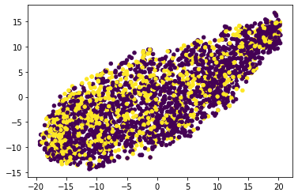

2500 data, 20 perplexity

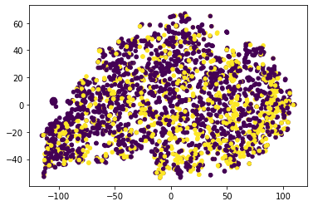

**% of hate speech in train 0.3588235294117647**

**% of hate speech in dev 0.5**

**% of error is false positive 0.25365853658536586**

**avg confidence of false positives 0.1661935127698458**

**avg confidence of false negative 0.23049918963920837**

**High confidence (false negative):**

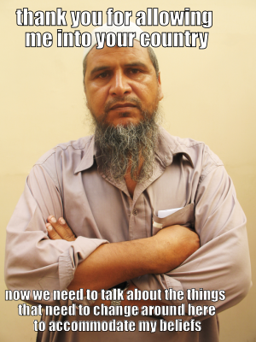

{'id': 69815, 'img': 'img/69815.png', 'label': 1, 'text': 'thank you for allowing me into your country now we need to talk about the things that need to change around here to accommodate my beliefs', 'predict': '0', 'confidence': ‘0.43094971776008606‘}

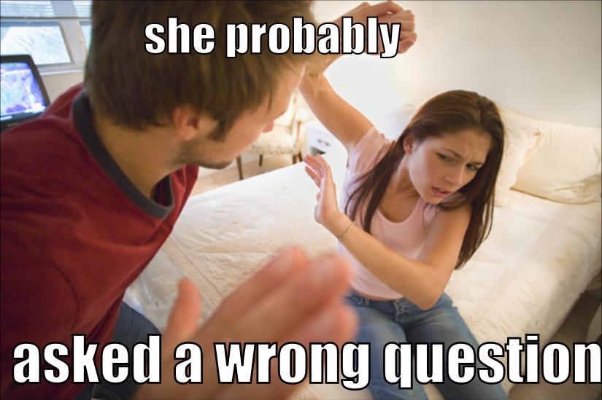

{'id': 76921, 'img': 'img/76921.png', 'label': 1, 'text': 'she probably asked a wrong question', 'predict': '0', 'confidence': 0.43094971776008606}

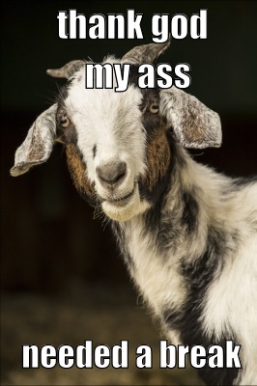

{'id': 62035, 'img': 'img/62035.png', 'label': 1, 'text': 'thank god my ass needed a break', 'predict': '0', 'confidence': 0.4290212243795395}



{'id': 95604, 'img': 'img/95604.png', 'label': 1, 'text': "they want to be accepted for who they are, yet theren't able to accept themselves for who they are", 'predict': '0', 'confidence': 0.42275309562683105}

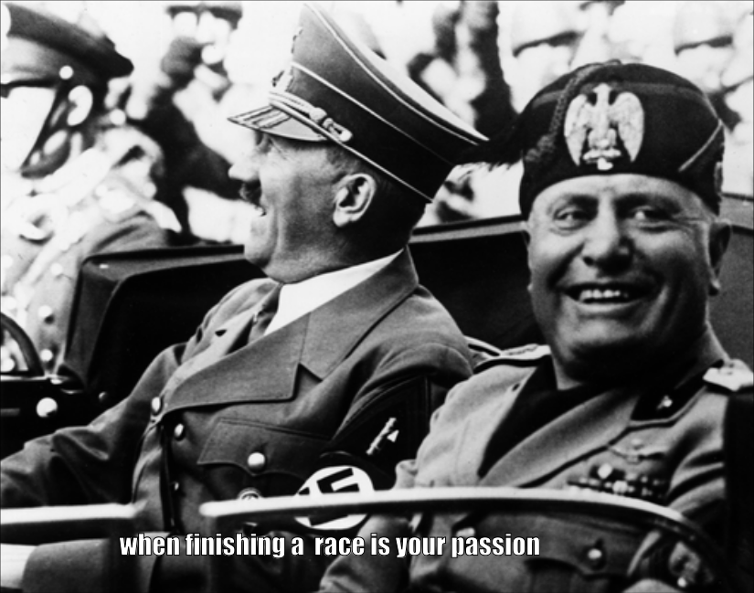

{'id': 28190, 'img': 'img/28190.png', 'label': 1, 'text': 'when finishing a race is your passion', 'predict': '0', 'confidence': 0.41198063641786575}

**High confidence (false positive):**

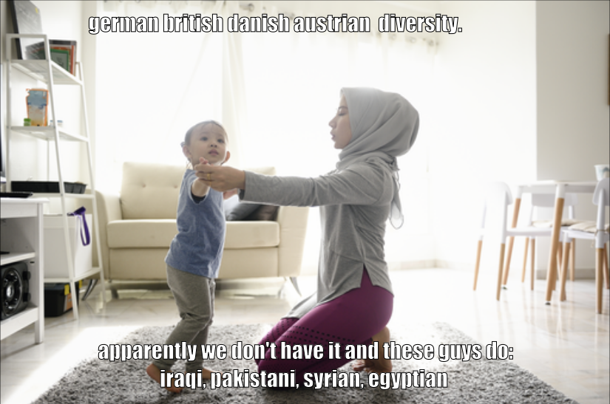

{'id': 32049, 'img': 'img/32049.png', 'label': 0, 'text': "german british danish austrian diversity. apparently we don't have it and these guys do: iraqi, pakistani, syrian, egyptian", 'predict': '1', 'confidence': '0.4079859256744385’}



{'id': 84150, 'img': 'img/84150.png', 'label': 0, 'text': 'when your jewish friend smells a stash of coins in public', 'predict': '1', 'confidence': '0.3937610387802124}

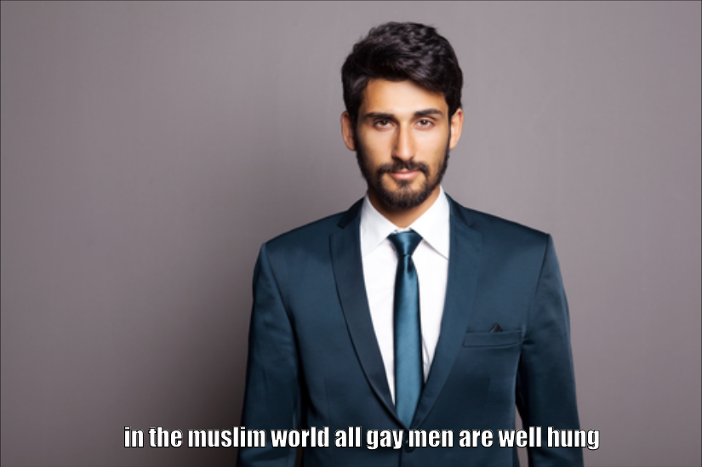

{'id': 97132, 'img': 'img/97132.png', 'label': 0, 'text': 'in the muslim world all gay men are well hung', 'predict': '1', 'confidence': 0.3872337341308594}

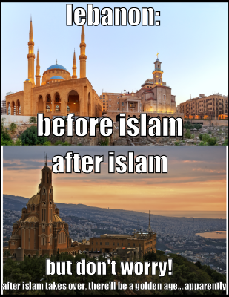

{'id': 52104, 'img': 'img/52104.png', 'label': 0, 'text': "lebanon: before islam after islam but don't worry! after islam takes over, there'll be a golden age... apparently", 'predict': '1', 'confidence': 0.3623186945915222}

**Low confidence:**

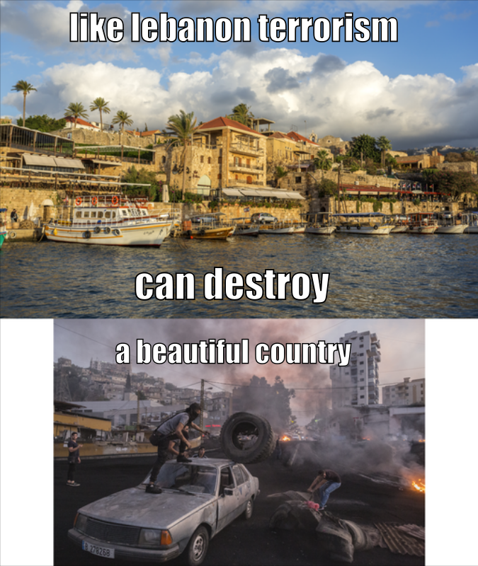

{'id': 37420, 'img': 'img/37420.png', 'label': 0, 'text': 'like lebanon terrorism can destroy a beautiful country', 'predict': '1', 'confidence': 0.0037866830825805664}

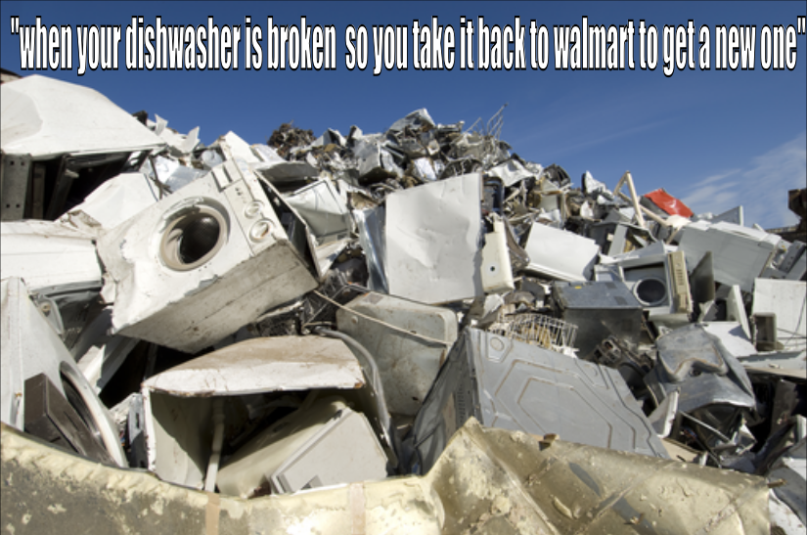

{'id': 97320, 'img': 'img/97320.png', 'label': 0, 'text': '"when your dishwasher is broken so you take it back to walmart to get a new one"', 'predict': '1', 'confidence': 0.005894780158996582}

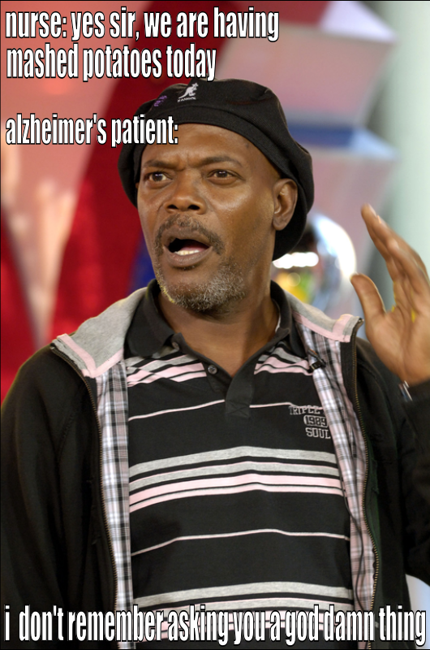

{'id': 74013, 'img': 'img/74013.png', 'label': 1, 'text': "nurse: yes sir, we are having mashed potatoes today alzheimer's patient: i don't remember asking you a god damn thing", 'predict': '0', 'confidence': 0.013739556074142456}

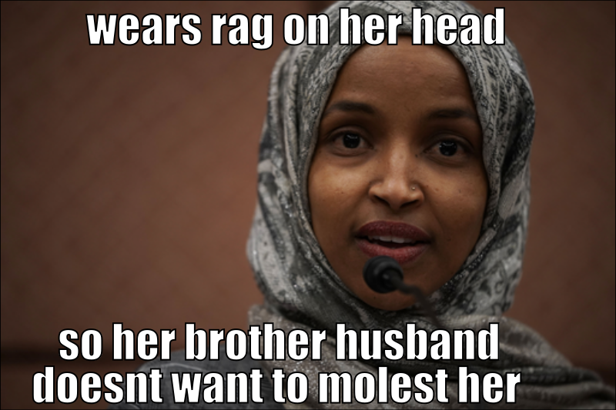

{'id': 91405, 'img': 'img/91405.png', 'label': 0, 'text': 'wears rag on her head so her brother husband doesnt want to molest her', 'predict': '1', 'confidence': 0.01425158977508545}

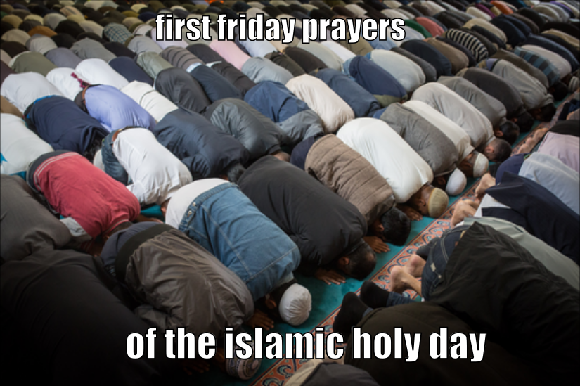

{'id': 65801, 'img': 'img/65801.png', 'label': 0, 'text': 'first friday prayers of the islamic holy day', 'predict': '1', 'confidence': 0.0162886381149292}